PROJECT REPORT ON
“LUNA ONLINE SHOPPING WITH AI CHATBOT”
Submitted in Partial fulfillment of the requirement for the award of the degree of
BACHELOR’S DEGREE OF COMPUTER APLLICATIONS
SUBMITTED BY
KENITH PAUL GNANARAJ

Mrs. R.DIVYA (MCA)..,M.phil
Pg Department Of Computer Science and Applications


(Affiliated to University Madras)
PERI Knowledge Park, Mannivakkam -Chennai-48

2022-2025

synopsis

SYNOPSIS
LUNA Online Shopping with AI CHATBOT is a smart and user-friendly e-commerce platform that integrates artificial intelligence to enhance the shopping experience. The AI-powered CHATBOT serves as a virtual shopping assistant, helping users find products, compare prices, and provide personalized recommendations based on their preferences and browsing history.

With LUNA, customers can enjoy a seamless shopping journey, from product discovery to checkout, with the CHATBOT offering real-time support, answering queries, and suggesting the best deals. The platform leverages AI-driven analytics to understand customer behavior, improve inventory management, and optimize sales strategies for businesses.

The platform integrates smart search capabilities, secure payment options, and real-time order tracking, ensuring convenience and reliability. Businesses benefit from AI-driven analytics that optimize inventory management, customer engagement, and sales strategies. With its intelligent automation, LUNA not only enhances user satisfaction but also streamlines business operations, making online shopping more intuitive, efficient, and personalized than ever before.

LUNA aims to revolutionize the online shopping experience by combining convenience, efficiency, and intelligent automation, making it easier than ever for users to shop smartly and effortlessly.

Introduction

CHAPTER-1
INTRODUCTION
In today's fast-paced digital world, online shopping has become an essential part of our daily lives. Luna Online Shopping takes this experience to the next level by integrating a cutting-edge AI CHATBOT, making shopping smarter, faster, and more convenient than ever.Luna’s AI-powered CHATBOT acts as your personal shopping assistant, helping you find products, compare prices, track orders, and even provide personalized recommendations based on your preferences. Whether you’re looking for fashion, electronics, or home essentials, Luna ensures a seamless and interactive shopping journey.
1.1 SYSTEM STUDY:
The system study of LUNA Online Shopping with AI CHATBOT involves analyzing its structure, functionality, and components to understand how it enhances the online shopping experience. Below are the key aspects of the system study:

1. System Overview
LUNA integrates an AI-powered CHATBOT into an e-commerce platform to provide personalized shopping assistance. It interacts with users, understands their preferences, and offers recommendations, making online shopping more intuitive and efficient.

2. Functional Requirements
- User Authentication: Secure login and account management.
- Product Search & Recommendations: AI-driven suggestions based on user behavior.
- CHATBOT Assistance: Instant query resolution and order tracking.
- Cart & Checkout Process: Seamless shopping cart management and payment integration.
- Order Management: Real-time order tracking and history.
- Customer Support: 24/7 AI-based assistance for queries and complaints.

3. Non-Functional Requirements
- Scalability: Handles multiple user interactions simultaneously.
- Security: Protects user data and payment information.
- Usability: Easy-to-navigate interface for smooth user experience.
- Performance: Fast response times and minimal latency.

4. System Architecture
- Frontend: User interface for browsing and interacting with the CHATBOT.
- Backend: AI engine, database, and business logic for processing requests.
- Database: Stores user data, product information, and transaction history.
- AI CHATBOT Engine: Processes natural language queries and provides responses.

5. Benefits of the System
- Enhanced User Experience: Personalized and interactive shopping.
- Time-Saving: Quick access to products and instant support.
- Improved Customer Engagement: AI-driven recommendations and order tracking.
- 24/7 Availability: Always accessible, reducing the need for human intervention.

Analysis of the problem
CHAPTER-2
ANALYSIS OF THE PROBLEM
2.1 SYSTEM ANALYSIS:
System analysis is the process of studying and evaluating the Luna Online Shopping with AI CHATBOT system to identify its requirements, functionalities, and potential improvements. It involves analyzing the system’s user interactions, data flow, AI integration, and performance to ensure efficient and seamless online shopping. This process helps in understanding how the AI CHATBOT enhances customer experience, optimizes operations, and resolves existing challenges in the e-commerce platform.
2.1.1 EXISTING SYSTEM:
Several existing e-commerce platforms have successfully integrated AI-powered chatbots to enhance the online shopping experience, similar to Luna Online Shopping with AI Chatbot. For example, Amazon uses AI-driven recommendations and its virtual assistant, Alexa, to help customers find products, track orders, and provide personalized shopping suggestions. eBay's ShopBot is another example, which allows users to search for products using natural language and even images, making the shopping experience more interactive. H&M's AI chatbot assists customers by suggesting outfits based on their style preferences, while Sephora’s Virtual Artist provides beauty recommendations through AI-powered chat. These systems improve customer engagement, reduce response time, and enhance personalization, making online shopping more convenient and efficient.
2.2.1 LIMITATIONS IN EXISTING SYSTEM:
Despite the advancements in AI-powered chatbots in e-commerce platforms like Amazon, eBay, H&M, and Sephora, there are still some limitations:
- Limited Understanding of Complex Queries – AI chatbots may struggle to understand ambiguous or highly detailed customer inquiries, leading to inaccurate responses.
- Dependency on Data Quality – The effectiveness of AI recommendations depends on the accuracy and volume of customer data, which can sometimes be incomplete or outdated.
- Lack of Human-Like Interaction – While AI chatbots can simulate conversations, they may lack the emotional intelligence and problem-solving capabilities of human agents.
- Handling of Unique or Uncommon Issues – AI chatbots perform well with standard queries but may fail to resolve unusual or complex issues, requiring human intervention.
- Limited Multilingual Support – Some AI-powered chatbots struggle with multiple languages or dialects, which can affect the shopping experience for non-English speakers.
- Security and Privacy Concerns – As AI chatbots collect and process customer data, there is a risk of data breaches or misuse if not managed securely.
- Technical Glitches and System Downtime – Chatbots rely on continuous internet connectivity and system updates, and any disruption can impact customer support and sales.
2.1.3 PROPOSED SYSTEM:
The proposed system for Luna Online Shopping integrates an AI-powered chatbot to enhance the online shopping experience by providing real-time assistance, personalized recommendations, and automated customer support. This system overcomes the limitations of existing e-commerce platforms by leveraging advanced AI, machine learning, and natural language processing (NLP) for better interaction and efficiency.

Key Features of the Proposed System:
- Smart Product Recommendations – The AI chatbot analyzes user behavior, preferences, and purchase history to suggest relevant products.
- 24/7 Customer Support – Unlike human agents, the chatbot provides instant responses to customer queries at any time.
- Voice and Text-Based Assistance – Supports both text and voice commands for a more interactive shopping experience.
- Automated Order Tracking & Updates – Users can check their order status, expected delivery date, and shipping details through the chatbot.
- Personalized Shopping Experience – AI adapts to customer preferences and offers customized promotions and discounts.
- Secure Payment Assistance – Guides users through the checkout process with enhanced security measures.
- Multilingual Support – Provides customer assistance in multiple languages for a global reach.
- Seamless Integration with Mobile and Web – Ensures a smooth experience across different devices and platforms.

Advantages of the Proposed System:
- Faster and More Efficient Customer Service – Reduces wait times and improves customer satisfaction.
- Higher Sales Conversions – Personalized suggestions lead to increased purchases.
- Reduced Cart Abandonment – AI assists customers in completing their transactions.
- Cost-Effective – Reduces dependency on human customer service agents, lowering operational costs.
- Enhanced Data Security – Implements strict privacy measures to protect customer information.
By integrating AI-powered chatbot technology, Luna Online Shopping creates a smarter, more engaging, and efficient shopping experience, addressing the shortcomings of existing e-commerce systems.

Disadvantages of the Proposed System:
• Limited Understanding of Complex Issues: AI chatbots may struggle with complex or unique queries, requiring human intervention for resolution.
• Dependency on Data: Poor-quality or incomplete customer data can result in inaccurate recommendations and responses.
• High Initial Cost: Developing and implementing the AI system can be expensive, particularly for smaller businesses.
• Security and Privacy Risks: Storing sensitive customer data can expose the system to potential data breaches or cyberattacks.
• Overreliance on Automation: Excessive automation may reduce the personal touch needed for certain customer issues, leading to dissatisfaction.
• Lack of Emotional Intelligence: AI chatbots can't provide empathy, which can be important for handling sensitive customer interactions.
• Ongoing Maintenance: The system requires constant updates and monitoring to remain effective and up-to-date.
• Limited Multilingual Support: AI chatbots may struggle with regional dialects or cultural nuances, affecting communication in diverse markets.
• System Downtime: Technical issues or outages can disrupt customer service and shopping experiences.
• Customer Resistance: Some customers may prefer human support and be frustrated with AI-driven interactions.
2.1.4 FEASIBILITY STUDY:
A feasibility study assesses the practicality of implementing the AI-powered CHATBOT system for Luna Online Shopping. It evaluates the technical, operational, economic, and legal aspects to ensure the project is viable and sustainable.

Technical Feasibility
- Infrastructure Requirements: Implementing an AI CHATBOT requires advanced infrastructure, including cloud-based servers, data storage systems, and robust security protocols.
- AI and NLP Technology: The development of an AI-powered CHATBOT requires cutting-edge technologies in Natural Language Processing (NLP), machine learning, and deep learning to understand and respond to customer queries accurately.
- Integration with E-Commerce Platform: The AI CHATBOT needs to be seamlessly integrated with the existing online store platform, payment gateways, and databases to provide a unified experience.
- Maintenance and Updates: The system will require continuous updates and fine-tuning to stay relevant, improve accuracy, and handle evolving customer behavior and market trends.

2. Operational Feasibility
- Customer Support Efficiency: The AI chatbot will provide 24/7 assistance, handling customer queries instantly and reducing the need for human agents. It will handle routine inquiries, allowing human agents to focus on complex issues.
- Employee Training: Staff will need training to manage and monitor the AI chatbot, especially for escalation scenarios or situations requiring human intervention.
- Scalability: The system can be scaled easily as the business grows, adding new products, languages, or expanding to new markets without significant extra effort.

3. Economic Feasibility
- Initial Investment: Developing the AI chatbot will require substantial initial investment in technology, development, and infrastructure. However, the cost is often offset by long-term savings in customer support and operational efficiency.
- Cost Reduction: Over time, the need for human agents can be reduced, leading to cost savings in customer support. Additionally, increased sales through personalized recommendations and improved customer engagement can boost revenue.
- ROI: The system’s ability to improve customer satisfaction, reduce cart abandonment, and increase sales conversion rates can provide a solid return on investment.

4. Legal Feasibility
- Data Privacy and Security: The chatbot will need to comply with data protection regulations (e.g., GDPR, CCPA) to ensure that customer information is handled securely. Encryption, secure data storage, and clear privacy policies will be essential.
- Consumer Protection Laws: The system must adhere to consumer rights and regulations related to returns, refunds, and dispute resolution, ensuring the chatbot’s actions are aligned with legal requirements.
5. Social Feasibility
- Customer Acceptance: Customers may be skeptical or resistant to AI-driven support. Offering a balance between AI and human support can help ease this transition.
- Market Demand: The increasing preference for convenience, instant responses, and personalized shopping experiences indicates a strong demand for AI-enhanced online shopping services.

CHAPTER-3
DATABASE STRUCTURE
The database structure for Luna Online Shopping with an AI Chatbot would typically consist of multiple tables to store various types of data related to the e-commerce platform and chatbot interactions. Below is a general schema for such a system:

Table 1 (user table)
Column Name | Data Type | Description
User _id | INT (PK) | Unique ID for each user
Name | VARCHAR(255) | Unique ID for each user
Email | VARCHAR(255) | Email address
Password_hash | VARCHAR(255) | Encrypted password
Phone | VARCHAR(15) | Contact number
Address | TEXT | Shipping/billing address
Created_at | TIMESTRAP | Account creation date

Table 2 (product table)

Column Name | Data Type | Description
product_id | INT (PK) | Unique product ID
name | VARCHAR(255) | Product name
Description | TEXT | details
Price | DECIMAL(10,2) | Product price
Stock | INT | Available stock count
category_id | INT (FK) | Category reference
image_url | VARCHAR(255) | Link to product image
created_at | TIMESTAMP | Date added to inventor
Table 3 (categories table)
Column Name | Data Type | Description
category_id | INT (PK) | Unique category ID
name | VARCHAR(255) | Category name
description | TEXT | Category details
Created_at | TIMESTAMP | Category Quality
Table 4(Order table)
Column Name | Data Type | Description
Order_id | INT(PK) | Unique order id
User_id | INT(FK) | Customer order
Total Amount | DECIMAL(10,2) | Total cost of the order
Status | ENUM | Order status
Created_at | TIMESTAMP | Order placement date

Table 5 (Order Items Table)
Column Name | Data Type | Description
order_item_id | INT (PK) | Unique ID
order_id | INT (FK) | Reference to Orders table
product_id | INT (FK) | Reference to Products table
quantity | INT | Number of items ordered
price | DECIMAL(10,2) | Price at time of purchase

Table 6 (CHATBOT Interactions Table)
Column Name | Data Type | Description
interaction_id | INT (PK) | Unique interaction ID
user_id | INT (FK) | User involve in chat
message_text | TEXT | Message content
response_text | TEXT | Chatbot response
created_at | TIMESTAMP | Timestamp of interaction

Table 7 (Payments Table)
Column Name | Data Type | Description
payment_id | INT (PK) | Unique payment ID
order_id | INT (FK) | Order linked to payment
payment_method | ENUM | Card,Paypal,Crypto
amount | DECIMAL(10,2) | Amount Paid
status | ENUM | Pending,Complete,Failed
created_at | TIMESTAMP | Payment date

Table 8 (Reviews Table)
Column Name | Data Type | Description
review_id | INT (PK) | Unique review ID
user_id | INT (FK) | Product Being Review
product_id | INT (FK) | Product being reviewed
rating | INT (1-5) | Star Rating
review_text | TEXT | Written review
created_at | TIMESTAMP | Review date

Table 9 (Admin Table)
Column Name | Data Type | Description
admin_id | INT (PK) | Unique ID for admin
username | VARCHAR(255) | Admin username
password_hash | VARCHAR(255) | Encrypted password

Table 10 (Wishlist Table)
Column Name | Data Type | Description
wishlist_id | INT (PK) | Unique ID
user_id | INT (FK) | User who save product
product_id | INT (FK) | Product saved in wishlist

Table 11( Notifications Table)
Column Name | Data Type | Description
notification_id | INT (PK) | Unique ID
user_id | INT (FK) | User Reciving Notification
message | TEXT | Notification Content
created_at | TIMESTAMP | Date/time sent

How AI CHATBOT Works:
The CHATBOT interacts with users and provides:

- Product recommendations (based on browsing & past purchases).

- Order tracking (fetching order status from Orders table).

- Support assistance (FAQ, return policy, etc.).

- Personalized marketing (based on Wishlist & Reviews data).

- Smart replies using AI-driven NLP to respond naturally.

Database Relationships
Users → Can place Orders.

Orders → Contain multiple Order Items.

Products → Belong to Categories.

Users → Interact with the CHATBOT.

Payments → Link to Orders.

Reviews → Are written by Users for Products.

Software requirements and specifications

CHAPTER-4
SOFTWARE REQUIREMENTS AND SPECIFICATIONS

4.1 PRODUCT PERSPECTIVE
Luna Online Shopping is an AI-powered e-commerce platform designed to provide a seamless, personalized, and efficient shopping experience. The integration of an AI chatbot enhances customer interaction, automates queries, and improves user satisfaction by offering instant support and recommendations.

Luna Online Shopping operates as a web and mobile-based application integrated with an AI chatbot. It serves as an intermediary between customers and the vast range of products available on the platform. The AI chatbot interacts with users to facilitate product searches, answer queries, assist in transactions, and provide real-time support.

4.1.1 SYSTEM INTERFACE
- User Interface
1. this section provides a detailed description of all inputs and outputs from the system. It also gives a description of the hardware,software and communication and provides basic prototype of the user interface.

2. The protocol used shall be RESTFUL APIs.

3. The Port number used will be 443.

4. There shall be logical address of the system in IPv4 formate.

- Hardware Interface
1. Laptop/Desktop PC-The Luna Online Shopping with AI Chatbot application includes essential components like the CPU for processing, RAM for smooth multitasking, and storage for data handling. Users interact through input devices such as keyboards, mice, and touchpads, while network connectivity (Wi-Fi or Ethernet) ensures seamless communication with the online store and AI chatbot. Displays render the UI, and optional peripherals like webcams and microphones enable voice or video-based interactions with the system.
2. Mobile-The Luna Online Shopping with AI Chatbot application includes essential components like the mobile processor (CPU) for efficient task handling, RAM for smooth operation, and storage for managing user data. Users interact through touchscreens, using gestures for easy navigation, while mobile connectivity (Wi-Fi or cellular data) ensures seamless communication with the online store and AI chatbot. The mobile display adapts the UI for optimal viewing, and optional features like cameras and microphones support voice or video-based interactions.
- Software Interface
The Application was developed using HTML, CSS and REACT.JS for frontend and NODE.JS for backend and MONGO DB for database.
Software Environment:
Software Environment is a technical specification of requirement of software product. This specifies the environment for development, operation, and maintenance the product in the application.
OS: Windows XP And Android
SPFTWARE REQUREMENTS FOR PRESENT PROJECT:
- OPERATING SYSTEM: Windows XP
- FRONT END: HTML, CSS, REACT.JS
- SERVER SIDE:
- DATABASE: MONGO DB

CHAPTER-5
SYSTEM DESIGNE
5.1UML DIAGRAM
To represent the Luna Online Shopping system with an AI chatbot, we can use UML (Unified Modeling Language) diagrams such as Use Case Diagram, Class Diagram, and Sequence Diagram to visualize different components and interactions.
1. Use case Diagram
2. Class Diagram
3. Sequence Diagram
This are the diagrams are used to function in the LUNA online shopping app.
5.1.1 UML DIAGRAM(CHATBOT)
A UML (Unified Modeling Language) diagram for the AI chatbot in the Luna Online Shopping system visually represents how the chatbot interacts with users and other system components. It helps illustrate the chatbot’s role in customer assistance, including answering queries, providing product recommendations, and handling order tracking.
- Use Case Diagram – Shows how users interact with the chatbot.
- Class Diagram – Represents the chatbot’s components and their relationships.
- Sequence Diagram – Illustrates the chatbot’s workflow when handling a user query.
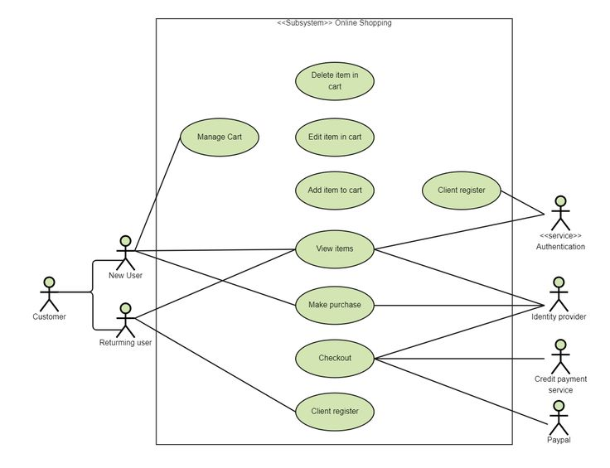

Figure5.1:use case diagram(online shopping)

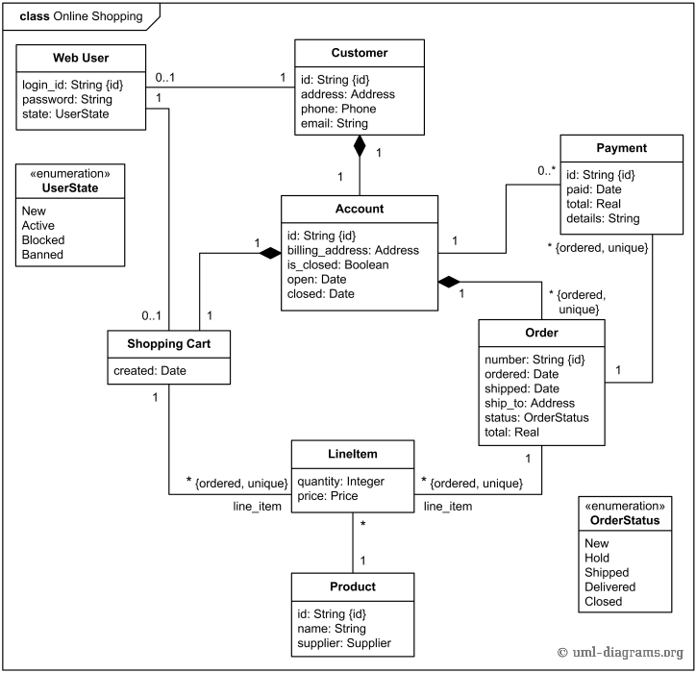

Figure5.2: Class Diagram(online shopping)

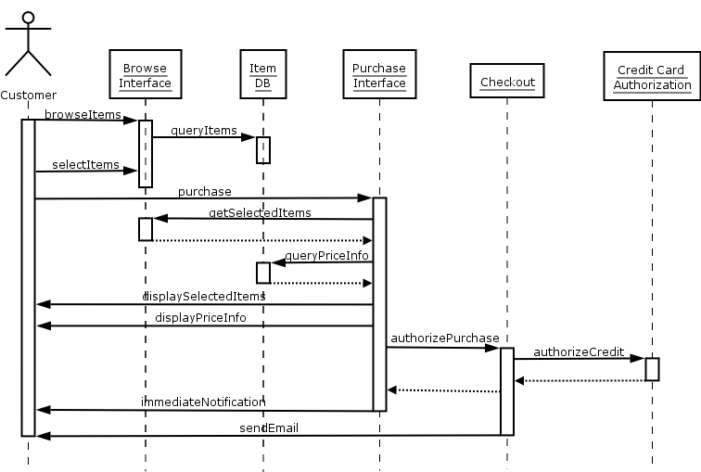

Figure5.3: Sequence Diagram(Online Shopping)

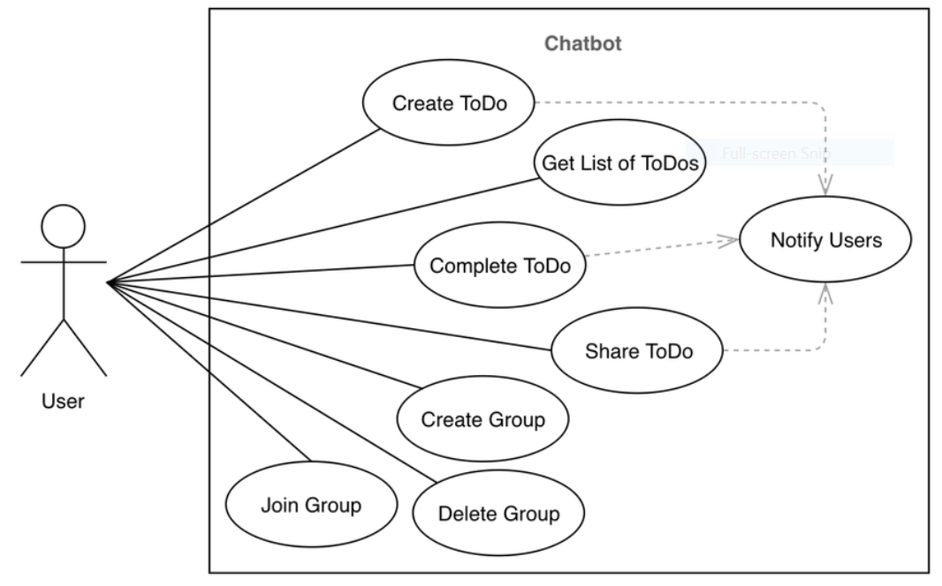
Figure5.4: Use Case Diagram(CHATBOT)

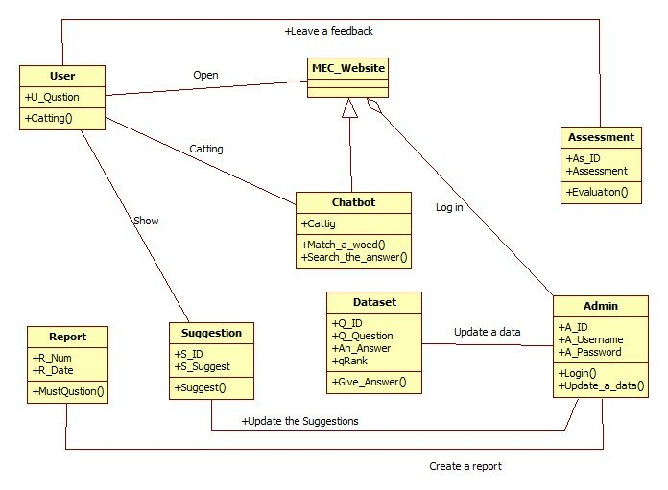

Figure5.5: Class Diagram(CHATBOT)

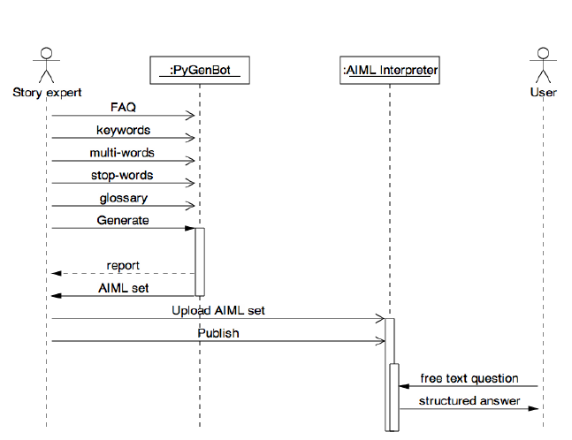

Figure5.6: Sequence Diagram(CHATBOT)

CHAPTER-6
DFD(DATA FLOW DIAGRAM)
CONTEXT LEVEL DIAGRAM:

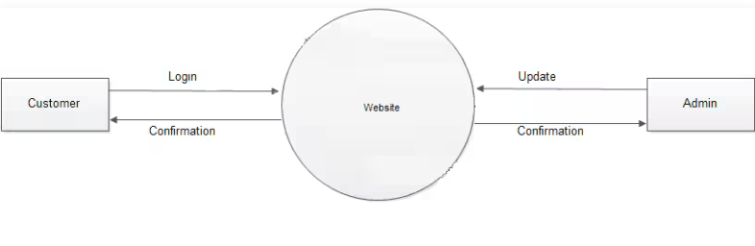DFD LEVEL -0
Figure6.1 CONTEXT LEVEL DFD

DFD LEVEL -1
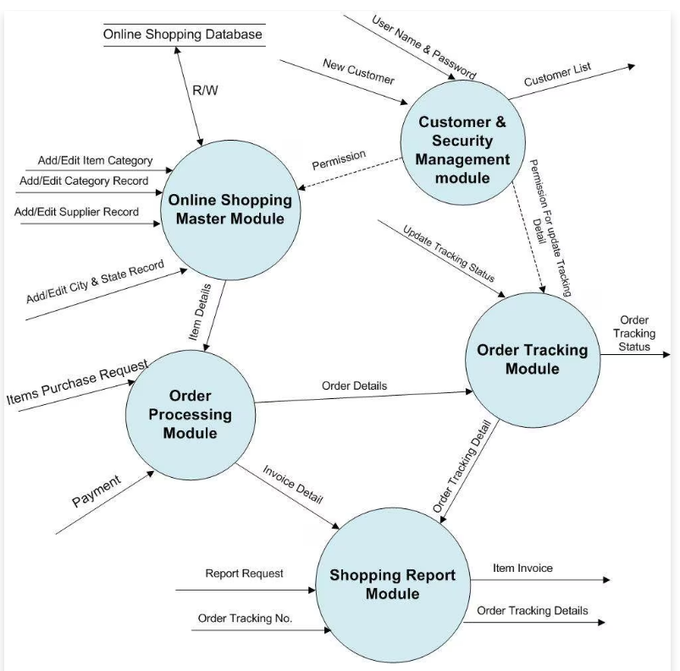
DFD LEVEL -1
Figure 6.2 LEVEL -1 DFD

DFD LEVEL – 2

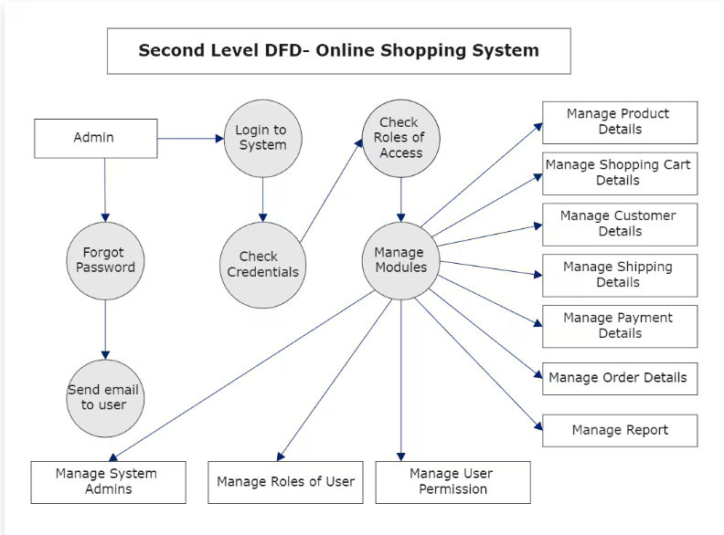
DFD LEVEL – 2

Figure6.3 LEVEL – 2 DFD

DFD LEVEL -0
CHATBOT

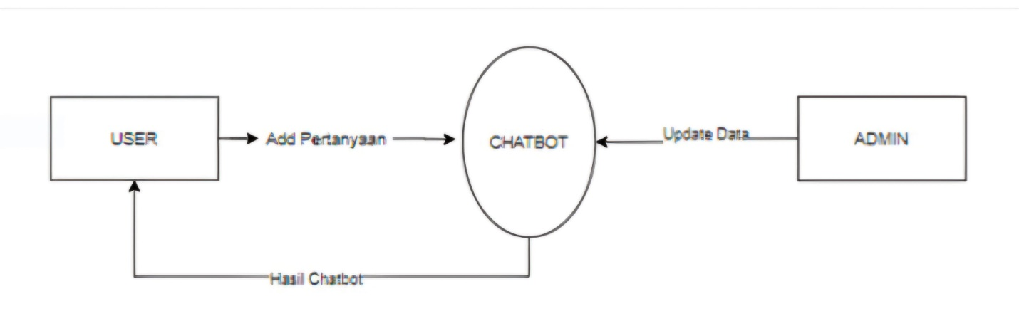

DFD LEVEL – 0
Figure6.4 LEVEL – 0 DFD

DFD LEVEL – 1
CHATBOT
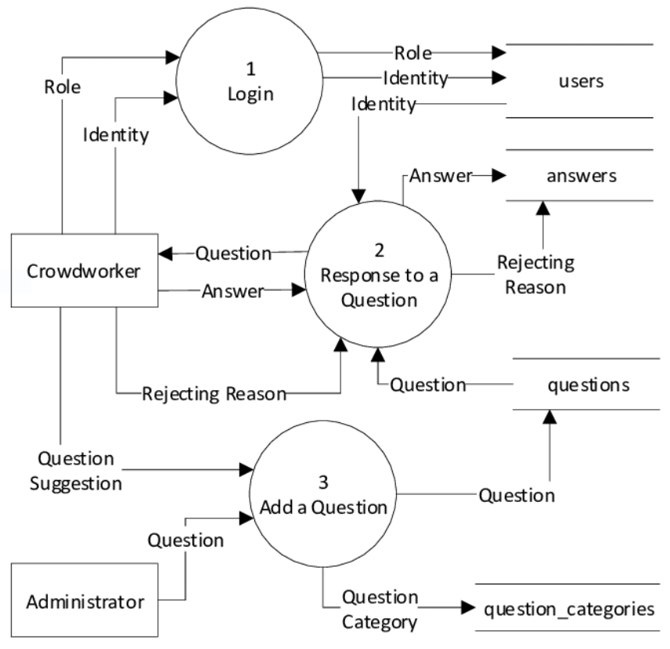
DFD LEVEL – 1
Figure6.5 LEVEL -1 DFD

Designe

CHAPTER-7
DESIGNE

7.1 ER DIAGRAM
7.2 DATA DESIGN
7.3 COMPONENT LEVEL DIAGRAM

7.1 ER DIAGRAM:

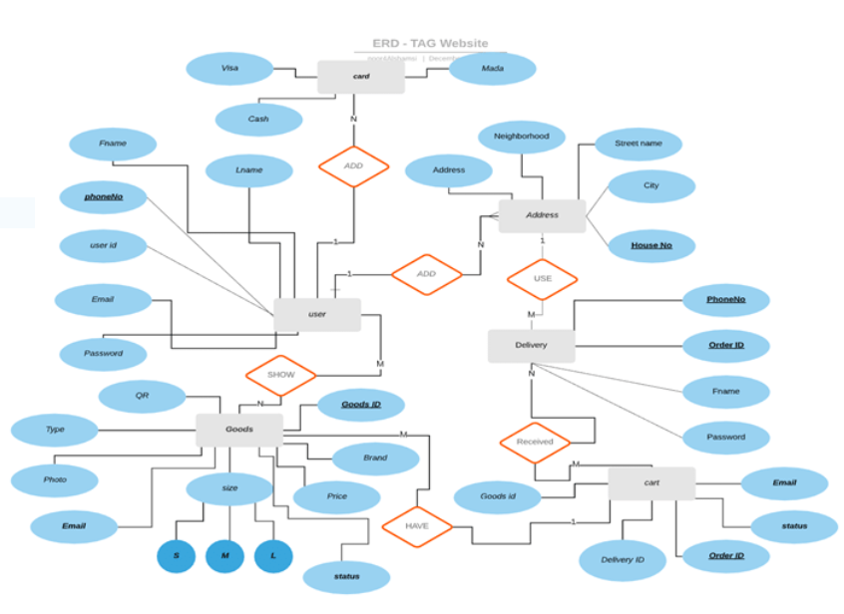
Figure7.1 ER DIAGRAM OF ONLINE SHOPPING

7.2 DATA DESIGN
1. USER TABLE:
CREATE TABLE Users (
user_id INT PRIMARY KEY AUTO_INCREMENT,
name VARCHAR(255),
email VARCHAR(255) UNIQUE,
password_hash VARCHAR(255),
phone VARCHAR(20),
address TEXT,
created_at TIMESTAMP DEFAULT CURRENT_TIMESTAMP
);

2. PRODUCT TABLE
CREATE TABLE Products (
product_id INT PRIMARY KEY AUTO_INCREMENT,
name VARCHAR(255),
description TEXT,
price DECIMAL(10,2),
stock_quantity INT,
category_id INT,
image_url VARCHAR(255),
created_at TIMESTAMP DEFAULT CURRENT_TIMESTAMP,
FOREIGN KEY (category_id) REFERENCES Categories(category_id)
);

3. CATEGORIES TABLE
CREATE TABLE Categories (
category_id INT PRIMARY KEY AUTO_INCREMENT,
category_name VARCHAR(255)
);
4.ORDER TABLE
CREATE TABLE Orders (
order_id INT PRIMARY KEY AUTO_INCREMENT,
user_id INT,
total_price DECIMAL(10,2),
order_status ENUM('Pending', 'Processing', 'Shipped', 'Delivered', 'Cancelled'),
created_at TIMESTAMP DEFAULT CURRENT_TIMESTAMP,
FOREIGN KEY (user_id) REFERENCES Users(user_id)
);
5. ORDER ITEM TABLE
CREATE TABLE Order_Items (
order_item_id INT PRIMARY KEY AUTO_INCREMENT,
order_id INT,
product_id INT,
quantity INT,
price DECIMAL(10,2),
FOREIGN KEY (order_id) REFERENCES Orders(order_id),
FOREIGN KEY (product_id) REFERENCES Products(product_id)
);

6. PAYMENT TABLE
CREATE TABLE Payments (
payment_id INT PRIMARY KEY AUTO_INCREMENT,
order_id INT,
user_id INT,
payment_method ENUM('Credit Card', 'PayPal', 'Bank Transfer'),
payment_status ENUM('Pending', 'Completed', 'Failed'),
transaction_id VARCHAR(255),
created_at TIMESTAMP DEFAULT CURRENT_TIMESTAMP,
FOREIGN KEY (order_id) REFERENCES Orders(order_id),
FOREIGN KEY (user_id) REFERENCES Users(user_id)
);

7. CHATBOT INTERACTION TABLE
CREATE TABLE Chatbot_Interactions (
interaction_id INT PRIMARY KEY AUTO_INCREMENT,
user_id INT,
message TEXT,
response TEXT,
timestamp TIMESTAMP DEFAULT CURRENT_TIMESTAMP,
FOREIGN KEY (user_id) REFERENCES Users(user_id)
);

8. REVIEW TABLE
CREATE TABLE Reviews (
review_id INT PRIMARY KEY AUTO_INCREMENT,
user_id INT,
product_id INT,
rating INT CHECK (rating BETWEEN 1 AND 5),
review_text TEXT,
created_at TIMESTAMP DEFAULT CURRENT_TIMESTAMP,
FOREIGN KEY (user_id) REFERENCES Users(user_id),
FOREIGN KEY (product_id) REFERENCES Products(product_id)
);

9. ADMINS TABLE
CREATE TABLE Admins (
admin_id INT PRIMARY KEY AUTO_INCREMENT,
name VARCHAR(255),
email VARCHAR(255) UNIQUE,
password_hash VARCHAR(255),
created_at TIMESTAMP DEFAULT CURRENT_TIMESTAMP
);

10.NOTIFICATION TABLE
CREATE TABLE Notifications (
notification_id INT PRIMARY KEY AUTO_INCREMENT,
user_id INT,
message TEXT,
status ENUM('Unread', 'Read'),
created_at TIMESTAMP DEFAULT CURRENT_TIMESTAMP,
FOREIGN KEY (user_id) REFERENCES Users(user_id)
);
11.WISHLIST TABLE
CREATE TABLE Wishlist (
wishlist_id INT PRIMARY KEY AUTO_INCREMENT,
user_id INT,
product_id INT,
created_at TIMESTAMP DEFAULT CURRENT_TIMESTAMP,
FOREIGN KEY (user_id) REFERENCES Users(user_id),
FOREIGN KEY (product_id) REFERENCES Products(product_id)
);

12. CHATBOT TRAINING DATA TABLE
CREATE TABLE AI_Training_Data (
training_id INT PRIMARY KEY AUTO_INCREMENT,
user_query TEXT,
chatbot_response TEXT,
timestamp TIMESTAMP DEFAULT CURRENT_TIMESTAMP
);

ADDITIONAL FEATURES
• AI Chatbot Features:
- AI-based product recommendations.
- Order tracking through chat.
- Automated responses for FAQs.
• User Activity Tracking:
- Track customer purchases and browsing history.
- Suggest products based on past orders.
• Admin Dashboard:
- Manage products, users, and orders.
- Monitor chatbot performance.

Testing

CHAPTER-8
TESTING

1.User Registration & Authentication Testing
✅ Test user sign-up with valid & invalid credentials.
✅ Verify login with correct and incorrect passwords.
✅ Check password reset functionality.
✅ Validate email verification (if applicable).

2. Product Management Testing
✅ Verify product listing, adding, updating, and deleting.
✅ Test product search and filtering by category, price, and ratings.
✅ Check if stock quantity updates correctly after purchase.

3. Shopping Cart & Wishlist Testing
✅ Add and remove items from the shopping cart.
✅ Ensure cart updates dynamically (price, quantity, stock validation).
✅ Test wishlist functionality (adding/removing products).

4. Order & Checkout Process Testing
✅ Place an order and verify payment processing.
✅ Test order status updates (Pending → Processing → Shipped → Delivered).
✅ Check order cancellation and refund policies.
✅ Validate order confirmation emails and notifications.

5. AI Chatbot Testing
✅ Test chatbot responses for product inquiries.
✅ Verify chatbot order tracking functionality.
✅ Check if chatbot handles FAQs correctly.
✅ Test chatbot fallback responses for unknown queries.

6. Payment Gateway Testing
✅ Test transactions with different payment methods (Credit Card, PayPal, etc.).
✅ Verify failed payments and refund processing.
✅ Ensure secure payment processing (SSL/TLS encryption).

7. Review & Rating Testing
✅ Post product reviews with different ratings.
✅ Verify reviews display correctly on product pages.
✅T Test review moderation (editing, deleting inappropriate content).

8. Admin Panel Testing
✅ Verify admin login and access control.
✅ Test product management (add/update/delete).
✅ Check order management and status updates.
✅ Validate AI chatbot training updates.

9. Notifications & Emails Testing
✅ Test order confirmation emails.
✅ Verify push notifications for order status updates.
✅ Ensure chatbot alerts work properly.

10. Performance & Security Testing
✅ Load testing (handling high traffic).
✅ SQL Injection, XSS, and CSRF security tests.
✅ Check AI chatbot response time and server load.
CODES:
import React from 'react';
import { render, screen, fireEvent } from '@testing-library/react';
import { BrowserRouter as Router } from 'react-router-dom';
import Cart from '../pages/Cart';

describe('Cart Component', () => {
const mockNavigate = jest.fn();
const mockSetCart = jest.fn();

// Mock the useNavigate hook from react-router-dom
jest.mock('react-router-dom', () => ({
...jest.requireActual('react-router-dom'),
useNavigate: () => mockNavigate,
}));

const sampleCart = [
{ id: '1', name: 'Product 1', price: 20, image: 'https://example.com/product1.jpg' },
{ id: '2', name: 'Product 2', price: 15, image: 'https://example.com/product2.jpg' },
];

test('renders empty cart message', () => {
render(
<Router>
<Cart cart={[]} setCart={mockSetCart} />
</Router>
);

expect(screen.getByText(/Your cart is empty./i)).toBeInTheDocument();
});
import React from 'react';
import { render, screen, fireEvent, waitFor } from '@testing-library/react';
import { BrowserRouter as Router } from 'react-router-dom';
import Checkout from '../pages/Checkout';
import axios from 'axios';

// Mock useNavigate hook
jest.mock('react-router-dom', () => ({
...jest.requireActual('react-router-dom'),
useNavigate: () => jest.fn(),
}));

// Mock axios for API calls
jest.mock('axios');

describe('Checkout Component', () => {
const mockNavigate = jest.fn();

beforeEach(() => {
jest.clearAllMocks();
});

test('renders CheckoutForm when order is not created', () => {
render(
<Router>
<Checkout cartItems={[]} />
</Router>
);

expect(screen.getByText(/Proceed to Checkout/i)).toBeInTheDocument();
});

test('shows loading indicator when submitting the form', async () => {
render(
<Router>
<Checkout cartItems={[]} />
</Router>
);

const submitButton = screen.getByText(/Proceed to Checkout/i);
fireEvent.click(submitButton);

expect(screen.getByRole('progressbar')).toBeInTheDocument();
});

test('displays error message when order creation fails', async () => {
axios.post.mockRejectedValue(new Error('An error occurred'));

render(
<Router>
<Checkout cartItems={[]} />
</Router>
);

const submitButton = screen.getByText(/Proceed to Checkout/i);
fireEvent.click(submitButton);

await waitFor(() => {
expect(screen.getByText('An error occurred')).toBeInTheDocument();
});
});

test('redirects to order success page on successful order creation', async () => {
axios.post.mockResolvedValue({ status: 201 });
render(
<Router>
<Checkout cartItems={[]} />
</Router>
);

const submitButton = screen.getByText(/Proceed to Checkout/i);
fireEvent.click(submitButton);

await waitFor(() => {
expect(mockNavigate).toHaveBeenCalledWith('/order-success');
});
});
});

import React from 'react';
import { render, screen } from '@testing-library/react';
import { BrowserRouter as Router } from 'react-router-dom';
import Home from '../pages/Home';
import userEvent from '@testing-library/user-event';

describe('Home Component', () => {
const mockAddToCart = jest.fn();

const sampleProducts = [
{
_id: '1',
name: 'Product 1',
price: 100,
description: 'Description for product 1',
image: 'https://example.com/product1.jpg',
},
{
_id: '2',
name: 'Product 2',
price: 200,
description: 'Description for product 2',
image: 'https://example.com/product2.jpg',
},
{
_id: '3',
name: 'Product 3',
price: 300,
description: 'Description for product 3',
image: 'https://example.com/product3.jpg',
},
];

test('renders the carousel with images', () => {
render(
<Router>
<Home products={[]} addToCart={mockAddToCart} error={null} loading={false} />
</Router>
);

// Check that the carousel images are rendered
expect(screen.getByAltText(/Summer Sale - Up to 50% Off/i)).toBeInTheDocument();
expect(screen.getByAltText(/New Tech Gadgets/i)).toBeInTheDocument();
expect(screen.getByAltText(/Trending Fashion/i)).toBeInTheDocument();
});

test('displays loading indicator when loading is true', () => {
render(
<Router>
<Home products={[]} addToCart={mockAddToCart} error={null} loading={true} />
</Router>
);

// Check for the CircularProgress component
expect(screen.getByRole('progressbar')).toBeInTheDocument();
});

test('displays error message when there is an error', () => {
const sampleError = { message: 'Failed to fetch products' };

render(
<Router>
<Home products={[]} addToCart={mockAddToCart} error={sampleError} loading={false} />
</Router>
);

// Check for the error message
expect(screen.getByText(/Failed to fetch products/i)).toBeInTheDocument();
});

test('renders featured products when available', () => {
render(
<Router>
<Home products={sampleProducts} addToCart={mockAddToCart} error={null} loading={false} />
</Router>
);

// Check for the presence of product names
expect(screen.getByText(/Product 1/i)).toBeInTheDocument();
expect(screen.getByText(/Product 2/i)).toBeInTheDocument();
expect(screen.getByText(/Product 3/i)).toBeInTheDocument();
});

test('renders "Shop Now" button correctly', () => {
render(
<Router>
<Home products={[]} addToCart={mockAddToCart} error={null} loading={false} />
</Router>
);

const shopNowButton = screen.getByRole('button', { name: /Shop Now/i });

// Check if the button is in the document
expect(shopNowButton).toBeInTheDocument();

// Simulate click to test navigation or any side effects
userEvent.click(shopNowButton);

// Check for correct href attribute
expect(shopNowButton.closest('a')).toHaveAttribute('href', '/shop');
});
});

import React from 'react';
import { render, screen } from '@testing-library/react';
import OrderSuccess from '../pages/OrderSuccess';

describe('OrderSuccess Component', () => {
test('renders success icon', () => {
render(<OrderSuccess />);

// Check for the success icon by its role
const successIcon = screen.getByTestId('CheckCircleOutlineIcon');
expect(successIcon).toBeInTheDocument();
});

test('displays order success message', () => {
render(<OrderSuccess />);

// Check for the success message
expect(screen.getByText(/Order Successful!/i)).toBeInTheDocument();
});

test('displays additional information message', () => {
render(<OrderSuccess />);

// Check for the additional information text
expect(screen.getByText(/Thank you for your purchase. Your order is being processed./i)).toBeInTheDocument();
});
});

import React from 'react';
import { render, screen, fireEvent, waitFor } from '@testing-library/react';
import { BrowserRouter as Router } from 'react-router-dom';
import axios from 'axios';
import ProductDetails from '../pages/ProductDetails';

// Mock useNavigate hook
jest.mock('react-router-dom', () => ({
...jest.requireActual('react-router-dom'),
useNavigate: () => jest.fn(),
useParams: () => ({ id: '1' }), // Mock the id parameter
}));

// Mock axios for API calls
jest.mock('axios');

describe('ProductDetails Component', () => {
const mockAddToCart = jest.fn();

const sampleProduct = {
_id: '1',
name: 'Sample Product',
brand: 'Brand A',
category: 'Category A',
price: 100,
description: 'This is a sample product description.',
image: 'https://example.com/product1.jpg',
stock: 10,
rating: 4,
numReviews: 5,
};

beforeEach(() => {
jest.clearAllMocks();
});

test('renders loading state initially', () => {
render(
<Router>
<ProductDetails addToCart={mockAddToCart} />
</Router>
);

// Check for the loading indicator
expect(screen.getByRole('progressbar')).toBeInTheDocument();
});

test('displays error message when there is an error', async () => {
axios.get.mockRejectedValue(new Error('Failed to load product details'));

render(
<Router>
<ProductDetails addToCart={mockAddToCart} />
</Router>
);

await waitFor(() => {
// Check for the error message
expect(screen.getByText(/Error loading product details/i)).toBeInTheDocument();
});
});

test('renders product details when data is fetched successfully', async () => {
axios.get.mockResolvedValue({ data: sampleProduct });

render(
<Router>
<ProductDetails addToCart={mockAddToCart} />
</Router>
);

await waitFor(() => {
// Check for the product name
expect(screen.getByText(/Sample Product/i)).toBeInTheDocument();
// Check for the brand
expect(screen.getByText(/Brand: Brand A/i)).toBeInTheDocument();
// Check for the category
expect(screen.getByText(/Category: Category A/i)).toBeInTheDocument();
// Check for the price
expect(screen.getByText(/\$100/i)).toBeInTheDocument();
// Check for the description
expect(screen.getByText(/This is a sample product description./i)).toBeInTheDocument();
// Check for the stock message
expect(screen.getByText(/10 Available/i)).toBeInTheDocument();
// Check for the rating and number of reviews
expect(screen.getByText(/\(5 Reviews\)/i)).toBeInTheDocument();
});
});

test('handles add to cart functionality', async () => {
axios.get.mockResolvedValue({ data: sampleProduct });

render(
<Router>
<ProductDetails addToCart={mockAddToCart} />
</Router>
);

await waitFor(() => {
const addToCartButton = screen.getByRole('button', { name: /Add to Cart/i });
fireEvent.click(addToCartButton);
expect(mockAddToCart).toHaveBeenCalledWith(sampleProduct);
});
});

test('handles rating change', async () => {
axios.get.mockResolvedValue({ data: sampleProduct });
axios.put.mockResolvedValue({ data: { ...sampleProduct, rating: 4.5, numReviews: 6 } });

render(
<Router>
<ProductDetails addToCart={mockAddToCart} />
</Router>
);

await waitFor(() => {
const ratingStars = screen.getByLabelText('4 Stars');
// eslint-disable-next-line testing-library/no-wait-for-side-effects
fireEvent.click(ratingStars);
});

await waitFor(() => {
// Check if the new rating was submitted
expect(axios.put).toHaveBeenCalledWith('http://localhost:5000/api/products/1/rating', { rating: 4.5 });
});
});
});

import React from 'react';
import { render, screen, fireEvent } from '@testing-library/react';
import Shop from '../pages/Shop';
import { BrowserRouter as Router } from 'react-router-dom';

describe('Shop Component', () => {
const mockAddToCart = jest.fn();

const sampleProducts = [
{ id: '1', name: 'Product 1', category: 'Electronics', price: 100, image: 'https://example.com/product1.jpg' },
{ id: '2', name: 'Product 2', category: 'Clothing', price: 200, image: 'https://example.com/product2.jpg' },
{ id: '3', name: 'Product 3', category: 'Electronics', price: 300, image: 'https://example.com/product3.jpg' },
{ id: '4', name: 'Product 4', category: 'Books', price: 150, image: 'https://example.com/product4.jpg' },
{ id: '5', name: 'Product 5', category: 'Clothing', price: 50, image: 'https://example.com/product5.jpg' },
{ id: '6', name: 'Product 6', category: 'Books', price: 250, image: 'https://example.com/product6.jpg' },
{ id: '7', name: 'Product 7', category: 'Electronics', price: 180, image: 'https://example.com/product7.jpg' },
];

beforeEach(() => {
jest.clearAllMocks();
});

test('renders Shop component with products', () => {
render(
<Router>
<Shop products={sampleProducts} addToCart={mockAddToCart} />
</Router>
);

// Check that the component displays the title
expect(screen.getByText(/Shop/i)).toBeInTheDocument();

// Check that the first few products are rendered
expect(screen.getByText(/Product 1/i)).toBeInTheDocument();
expect(screen.getByText(/Product 2/i)).toBeInTheDocument();
expect(screen.getByText(/Product 3/i)).toBeInTheDocument();
});

test('filters products by category', () => {
render(
<Router>
<Shop products={sampleProducts} addToCart={mockAddToCart} />
</Router>
);

// Select category 'Electronics'
fireEvent.mouseDown(screen.getByLabelText(/Filter by Category/i));
fireEvent.click(screen.getByText(/Electronics/i));

// Ensure that only products from the selected category are displayed
expect(screen.getByText(/Product 1/i)).toBeInTheDocument();
expect(screen.getByText(/Product 3/i)).toBeInTheDocument();
expect(screen.getByText(/Product 7/i)).toBeInTheDocument();

// Ensure that products from other categories are not displayed
expect(screen.queryByText(/Product 2/i)).not.toBeInTheDocument();
expect(screen.queryByText(/Product 4/i)).not.toBeInTheDocument();
});

test('displays pagination and handles page change', () => {
render(
<Router>
<Shop products={sampleProducts} addToCart={mockAddToCart} />
</Router>
);

// Check that pagination is rendered
const pagination = screen.getByRole('navigation');
expect(pagination).toBeInTheDocument();

// Verify initial state of the page
expect(screen.getByText(/Product 1/i)).toBeInTheDocument();
expect(screen.queryByText(/Product 7/i)).not.toBeInTheDocument();

// Simulate page change to 2
fireEvent.click(screen.getByRole('button', { name: /2/i }));

// Ensure products from the second page are displayed
expect(screen.getByText(/Product 7/i)).toBeInTheDocument();
expect(screen.queryByText(/Product 1/i)).not.toBeInTheDocument();
});

test('resets to first page on category change', () => {
render(
<Router>
<Shop products={sampleProducts} addToCart={mockAddToCart} />
</Router>
);

// Change to page 2
fireEvent.click(screen.getByRole('button', { name: /2/i }));
expect(screen.getByText(/Product 7/i)).toBeInTheDocument();

// Change category to 'Books'
fireEvent.mouseDown(screen.getByLabelText(/Filter by Category/i));
fireEvent.click(screen.getByText(/Books/i));

// Verify that it resets to the first page
expect(screen.getByText(/Product 4/i)).toBeInTheDocument();
expect(screen.getByText(/Product 6/i)).toBeInTheDocument();
expect(screen.queryByText(/Product 7/i)).not.toBeInTheDocument();
});
});

CHAPTER-9
CONCLUSION
Luna Online Shopping with AI Chatbot is designed to offer a seamless, efficient, and interactive shopping experience. The integration of AI enhances user engagement, automates responses, and provides personalized recommendations. Below are the key conclusions drawn from the system:
- Enhanced User Experience: The AI chatbot provides real-time assistance, guiding users in product selection, answering FAQs, and tracking orders, ensuring a smooth shopping journey.
- Efficient Product Management: A well-structured database enables easy product categorization, inventory tracking, and stock updates, ensuring accurate availability of items.
- Secure and Reliable Transactions: The system incorporates encrypted payment gateways, supporting multiple payment methods while ensuring data security and transaction reliability.
- Robust Order Processing: The end-to-end order management system ensures smooth order placement, tracking, and status updates, allowing users to stay informed about their purchases.
- User Engagement Through Reviews & Wishlist: Features like product reviews and wishlists enhance user interaction and help in decision-making, increasing customer satisfaction.
- Scalability & Performance Optimization: The platform is designed to handle high user traffic efficiently, ensuring fast response times from the chatbot and seamless system performance.
- AI-Driven Personalization: The chatbot analyzes user preferences and past purchases to provide personalized product recommendations, improving sales conversion.
- Secure & Role-Based Admin Control: The admin panel provides a controlled environment for managing users, orders, and chatbot training, ensuring smooth system operation.
- Automated Notifications & Alerts: Users receive instant notifications regarding order status, promotions, and chatbot updates, keeping them engaged with the platform.
- Comprehensive Testing & Security Measures: Rigorous testing procedures ensure the system remains secure, free from vulnerabilities like NODE.JS, XSS, and CSRF attacks.
In conclusion, Luna Online Shopping with AI Chatbot is an innovative e-commerce solution that integrates AI for intelligent shopping assistance. It enhances user experience, ensures secure transactions, and provides a scalable and reliable platform for online shopping. With continuous improvements and AI-driven insights, it can evolve into a more advanced and customer-friendly marketplace.

CHAPTER-10
SAMPLE SCREENSHOTS

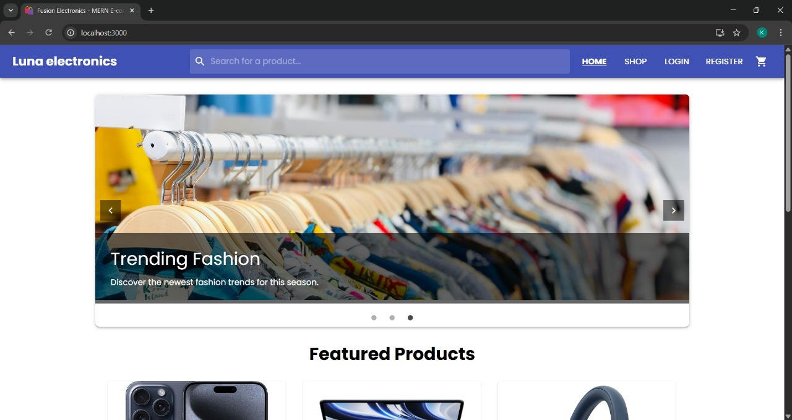

Figure10.1 HOME PAGE DASHBOARD

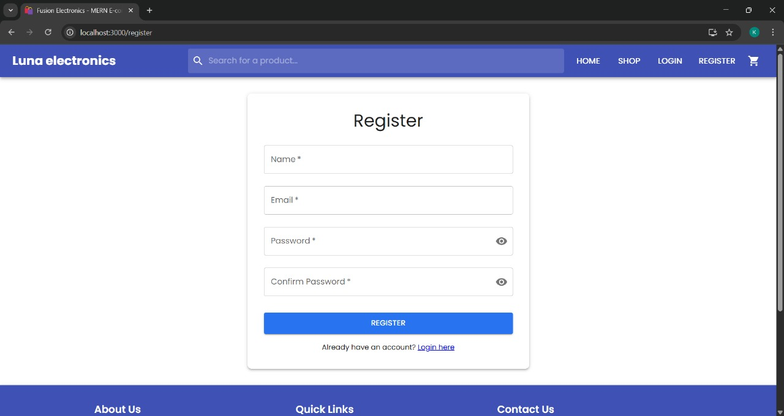
Figure10.2 REGISTER PAGE

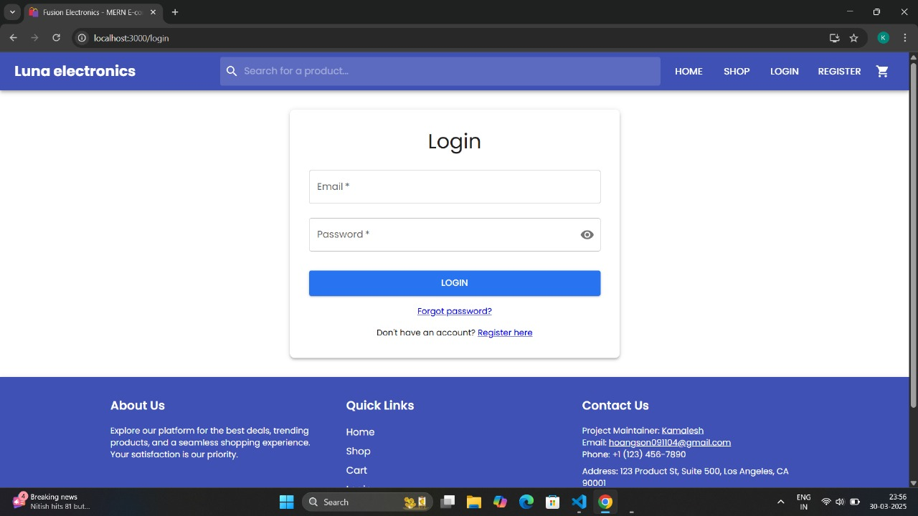
Figure10.3 LOGIN PAGE
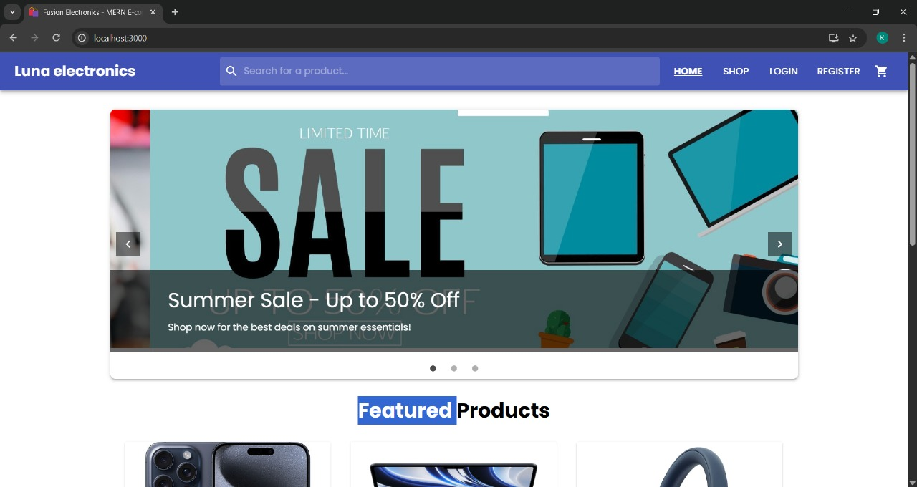
Figure10.4 SHOPPING PAGE
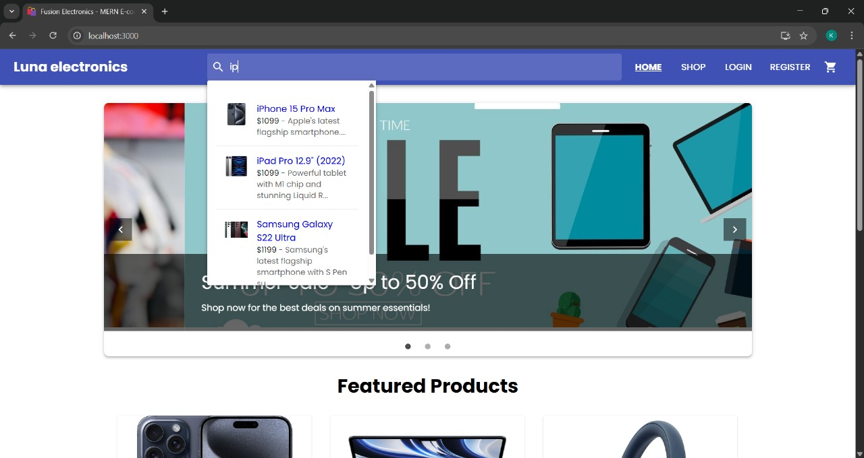
Figure10.5 SEARCH TAB

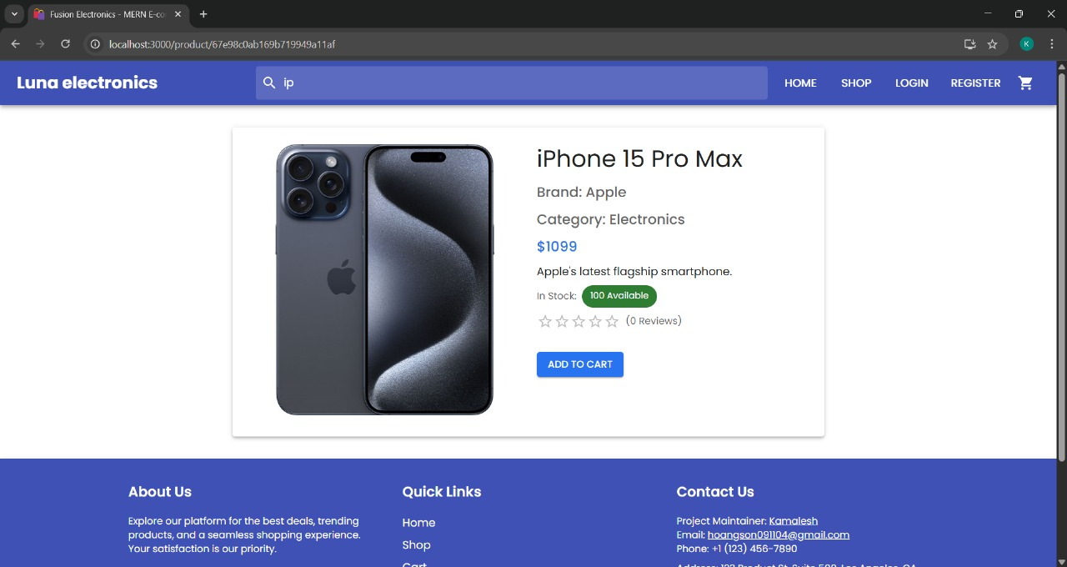

Figure10.6 PRODUCT ORDERING PAGE
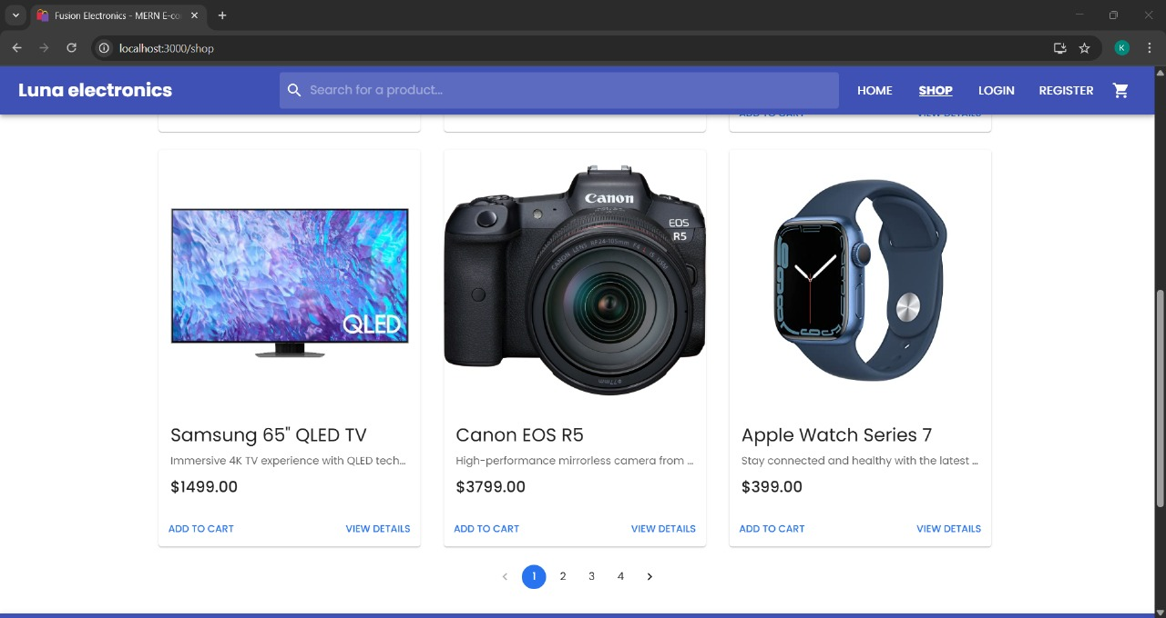
Figure10.7 PRODUCT PAGE

Appendix

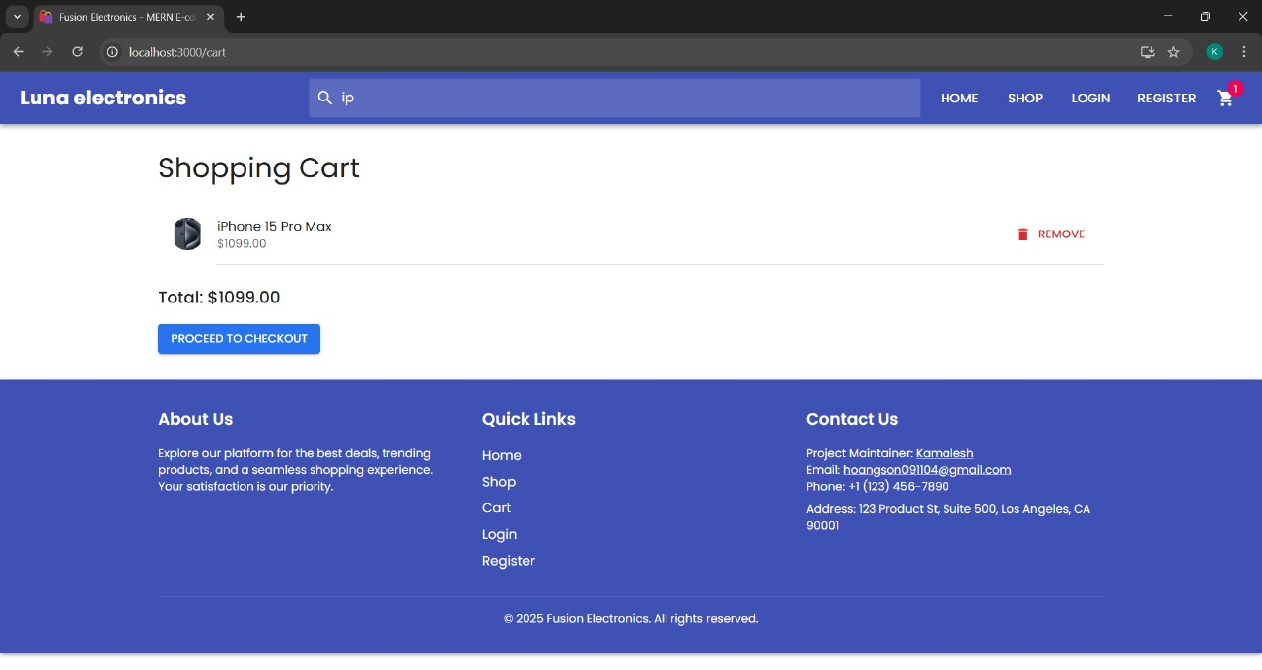
Figure10.8 SHOPPING CART
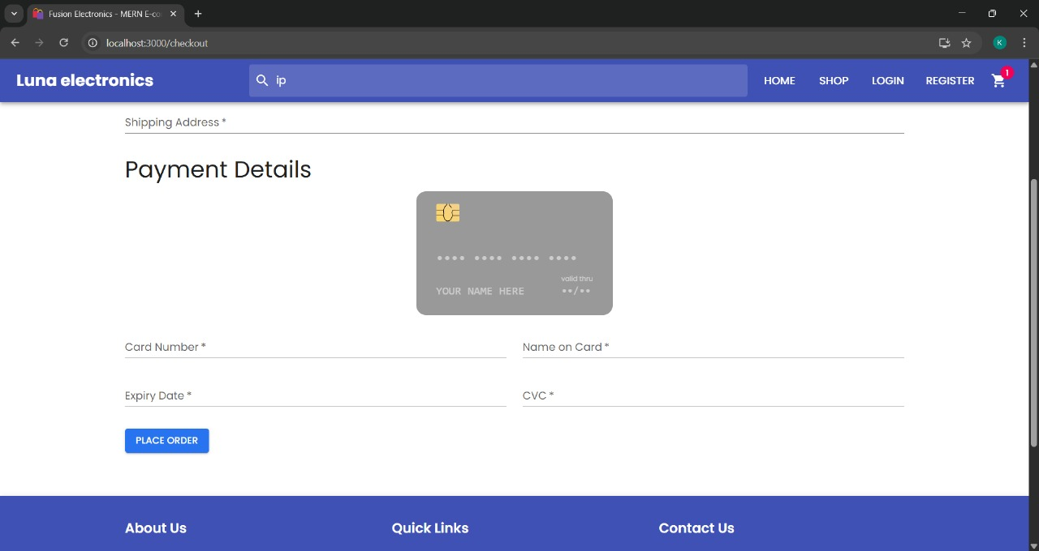
Figure10.9 PAYMENY PAGE

BIBLIOGRAPHY

CHAPTER-11
BIBLIOGRAPHY
https://www.tandfonline.com/doi/full/10.1080/08874417.2025.2456750?af=R
https://www.sciencedirect.com/science/article/abs/pii/S1567422323000698
https://www.researchgate.net/publication/384858828_THE_ADOPTION_OF_AI-DRIVEN_CHATBOTS_INTO_A_RECOMMENDATION_FOR_E-COMMERCE_SYSTEMS_TO_TARGETED_CUSTOMER_IN_THE_SELECTION_OF_PRODUCT
https://link.springer.com/article/10.1007/s12525-023-00633-8
https://www.sciencedirect.com/science/article/pii/S0148296324002418
https://www.emerald.com/insight/content/doi/10.1108/idd-11-2023-0132/full/pdf?title=chatbot-integration-for-online-shopping-a-bibliometric-review-and-future-research-agenda
https://www.igi-global.com/chapter/assessing-customer-interactions-with-chatbots-in-online-shopping-experiences/313843
https://www.researchgate.net/publication/372837440_Chatbots_in_Digital_Marketing_Enhanced_Customer_Experience_and_Reduced_Customer_Service_Costs
https://www.jatit.org/volumes/Vol102No19/29Vol102No19.pdf

Database Structure

DataFlow Diagram

System Design

